RGui (64

File Edit Packages Windows Help

R Graphics: Device 2 (ACTIVE)

R Console

Untitled - R Editor

$ x: chi "Time" return (vowel count) $ y: chi "Bcdy weight"

at of 2

$ x: chi " (days)"

$ y: chi " (gm)"

> summary (data)

# Inad the ChickWeight dataset we i ght Time Chi Ck Diet

data < —ChickWeighC Min SS. Min 1 : 220 data 1st Qu 63 1st Qu oo 2 • 120

 Medi an • 103 . Medi an oo • 120

# Explore Che summary of Che data sec • 121 Me an • 10 . 72 4 • 118 SCI (data) • 163 oo

summary (data) : 373 . Max . : 21 oo

(Ocher) : s06

tail (data, 6) Call (data, E)

weigh C Time Chick Diet

# Inad the dplyr I i bialy library (dpi yr) 20s

234 # Older Che data frame in as •ending o Ider by feature and g I oup by "diet 264

data 264 group by (Diet) arrange (weight)

# Load the data. Cable library

# Time

|  |  |  |  |  |  |  |  |  |
| --- | --- | --- | --- | --- | --- | --- | --- | --- |
| o |  |  |  |  |  |  | â 300c | 12:24 PM  1/29/2023 |
|  |  |  |  |  |  |  |  |

View Misc Packages Windows Help

R Graphics: 2 (ACTIVE)

R Consolț

Untitled - R Editor

|  |  |  |  |  |  |  |  |  |
| --- | --- | --- | --- | --- | --- | --- | --- | --- |
| acast (setDT (data) , un. aggzegate me an) | | |  |  |  | . 43127549 | 1 . 93225898 | 2 . 56675754 |
| sumnazy (data) |  |  |  | 13 06577405 | 20 . | 07560890 | 20 . | 12 07364193 |
| boxplot (weight DI et , data — data) hist (clata$weight ] ) |  |  |  | B. 57265844 | 07267496 |  | 6 069707gg | 4 . 56872451 |
| # Load the caz librar y  I ibzazy (caz)  scattezplot (weight Time I | data) |  |  | 06774102 | 18 . 56675754  g 07364193 | 23 06577405  3 . 57265844 | 20 .  07267496 | 32 07560890 |
| # Load the ggpIot2 I ibzazy  I ibzazy (ggpIot2) |  |  |  |  | 4 . 56872451 | 12 06774102 | 18 . 56675754 | 12 06577405 |
| ggplot (data, aes (x Time , y we ght , | color | as . factor (Diez) ) ) | ge om point O | 7 . 31528231 | 31 07560890  -n . 42930852 | 20 .  -13 . | 10 07364193  -25 . | 3 . 57265844  -14 . |
| # Create Che  < — I m (weight Time + Di et, | data) |  |  | -14 . 43324246 | -25 . | -37 . | 30 07560890 | 13 . |
| # Print the sumnazy of Che mcuNeI |  |  |  | 2 07364193 | 3 . 42734156 | 1 . 92832504 | 7 . 57069148 | 25 . 069707gg |
| sumnazy (mcdel) |  |  |  | 30 . | 46 06774102 | 30. | 34 06577405 | 28 . |
| zesiduals < residuals (mcuNeI)  # Print Che z e s iduals |  |  |  | 30 07560890 | 20 .  Time | 13 07364193 | 10 . | 07167496 |
| Activate Win | |

RGui (64

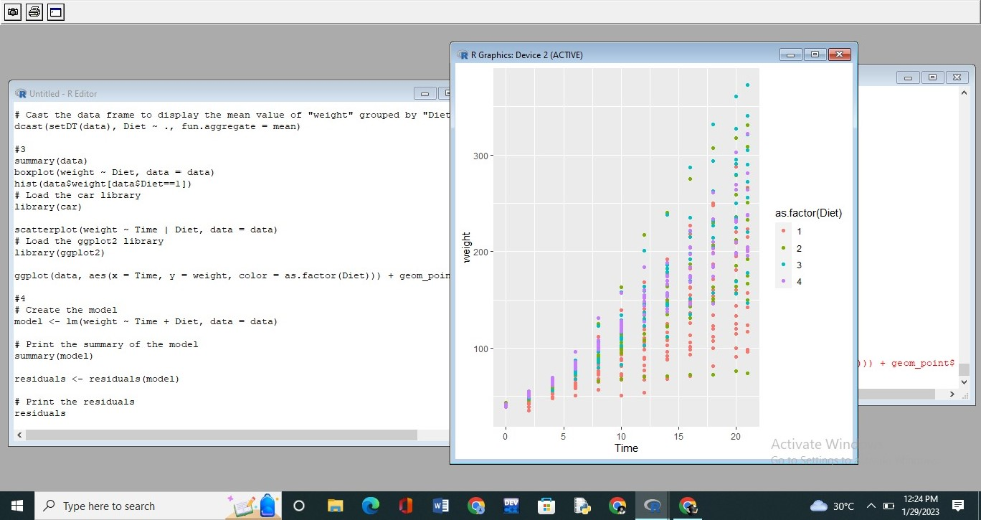

File

History

Resize

Windows

|  |  |  |  |  |  |  |
| --- | --- | --- | --- | --- | --- | --- |
| Untitled - R Editor |  | R Console |  |  |  |  |
|  |  | 40 83428484 | 62. 33330136 | 86 83231787 | 08182613 | 1 15784728 |
| # Create a random sample of S elements the | letters |  |  |  | ssg | 560 |
| sample letters < — sample (LETTERS, S) |  | . 65883076 | -12 15981425 | 8 . 66079773 | 16178122 | . 66276470 |
|  |  | s 61 | s 62 | 563 | 564 |  |
| # Create a factor from Che sample |  | 83625181 | 2 . 33526833 | 2 83428484 | 4 . 33330136 | 16.83231787 |
| sample factor < factor (sample letters) |  | 566 | 567 | 568 | s 69 | 570 |
|  |  | 12 08182613 | 0 15784728 | 4 . 65883076 |  | g . 66079773 |
| # Extract Che first five levels of Che factor |  |  | 572 | 573 | 574 |  |
| first five levels < — levels (sample factor) [I |  | -6 16178122  576 | -6. 66276470  577 | 8 83625181  578 | . 33526833 | 23 83428484 |
| # Print the first five levels |  | . 33330136 | 47 83231787 | 08182613 |  |  |

print (first five levels)

# Create a random sample of S elements from Che letters sample letters < — sample (LETTERS, S)

# Create a factor from Che sample a<—max (vec) sample factor < — factor (sample letters)

(vec)

range < —a—b

# Extract Che first five levels of Che factor ange

first five levels < — levels (sample factor) [L:SI

# Print Che first five levels find w:vels < function ( st I) { print (first five levels) vcvels < — c ("a" vcvel count < — length (grep (paste (l.mwels, col I aps e return (vowel cu:vunt)

Time



File Edit View Misc Packages Windows Help

R Consolț

Untitled - R Editor

> # the sunnazy of the model

acast (setDT (data) , un. aggzegate me an) > sunnazy (model)

|  |  |  |  |  |  |  |  |  |  |
| --- | --- | --- | --- | --- | --- | --- | --- | --- | --- |
|  | | |  |  |  | call • | |  |  |
| sumnazy (data) boxplot (weight DI et , data — data) | | | data) |  |  | Im (formula | | — Time + Di et, data  Med i an  -2. sgs 25 . 033  Sta . t val ue  3 . 3607 3 . 251  . 222B sg. 451 | data)  PI (> l t l )  o. 00122 |
| Min -136. 851  Time | -17  ents :  E stimate  . 9244  . 7505 |
| hist (clata$weight  # Load the caz librar y | | ] ) |
| I ibzazy (caz)  scattezplot (weight # Load the ggpIot2  I ibzazy (ggpIot2) | Time I  I ibzazy |
| ggplot (data, aes (x  # Create Che | Time , y | we ght , | color | as . factor (Diez) ) ) | ge om point O |  | 30 . 2335 | 1. . 957 oase 2. 1075 7 . 361 | 6. 39e- |
| < — I m (weight | Time + Di et, | | data) |  |  | Signif. ccaes: | | O. 001 o. 01 | os |

# Print the sumnazy of Che mcuNeI Residual standard erzor: 35. gg on 573 degzees of f z e edom sumnazy (mcdel) Multiple R —squazed: O . 7453, R —squazed : O . 7435

F—statistic: 41 g. 2 on 4 ana 573 DE, p-value: < 2.2e-16 zesiduals < residuals (mcuNeI)

# Print Che z e s iduals

# Time

â

Untitled - R Editor

tail (data, 6)

# Load Che dplyr I i b yary

I i bray y (dpi yr )

# Order Che data frame in as •ending order by "we i ghC " feature and g I oup by "diet data group by (Diet) arrange (weight)

# Load Che data. Cable I i b rary library (data . Cable)

# Melc Che data frame based on "Chick" "Time" and "Diet" as ID var i ab melt (set DT (data), id. vars c ("Chick" "Time", "Diet"))

# Load Che data. Cable library library (data . Cable)

# Cast Che data frame Co display Che mean value of "we i ghC " g I ouped by "Diet" dcast (setDT (data), Diet — fun . aggre gate mean)

summarv (data)

R Console

264

# Inad the dpi y: I i bra ry

I i bra: y (dpi y:)

# Older Che data frame in ascending o Edel by "weight" feature and group by "d$ data group by (Diet) arrange (weight) A "i bbl e: 578 x 4

131 cups : Diet [4) we i ghC Time Chick Diet

18

0 18

27

28

36

48

S 68 more rcvs

Use V print (n Co see more row s

# Time

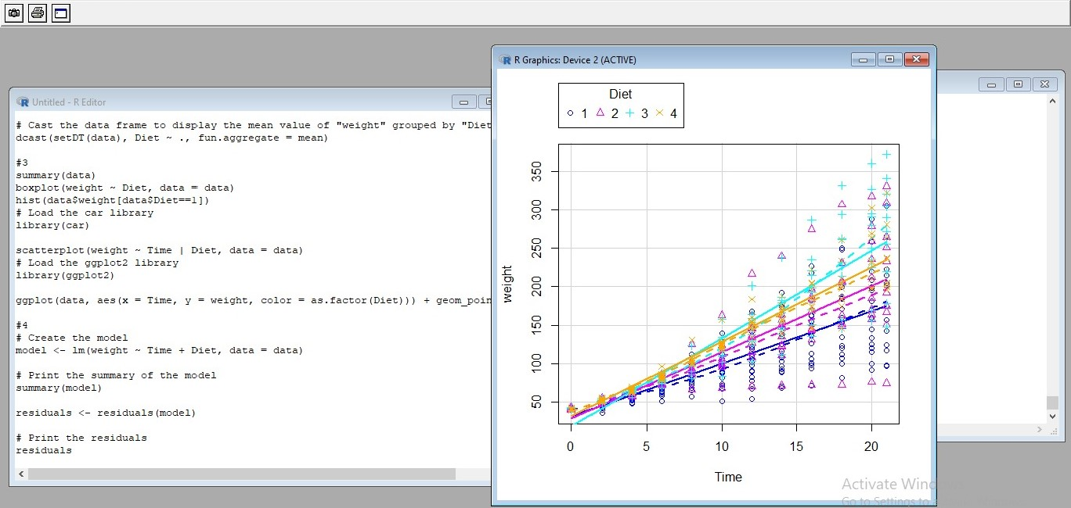History Resize

|  |  |  |  |  |  |  |  |
| --- | --- | --- | --- | --- | --- | --- | --- |
|  |  |  | R Console |  |  |  |  |
| Untitled - R Editor |  |  | 12 08182613 | 0 15784728 | 4 . 65883076 |  | g . 66079773 |
| # Create a random sample of S elements | the | letters |  | 572 | 573 | 574 |  |
| sample letters < — sample (LETTERS, S) |  |  | -6 16178122  576 | -6. 66276470  577 | 8 83625181  578 | . 33526833 | 23 83428484 |
| # Create a factor from Che sample sample factor < factor (sample letters) |  |  | . 33330136 | 47 83231787 | 08182613 |  |  |

# Create a random sample of S elements from Che letters

# Extract Che first five levels of Che factor sample letters < — sample (LETTERS, S) first five levels < — levels (sample factor) [I

# Create a factor from Che sample

# Print the first five levels sample factor < — factor (sample letters) print (first five levels)

# Extract Che first five levels of Che factor first five levels < — levels (sample factor) [L:SI

# Print Che first five levels a<—max (vec) print (first five levels)

(vec) range < —a—b

ange

> a<—max (vec) > (vec)

find w:vels < function ( st I) {

> range vcvels < — c ("a" vcvel count < — length (grep (paste (l.mwels, col I aps e return (vowel cu:vunt)

Time

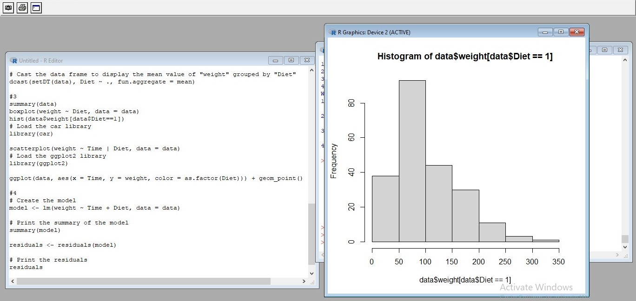History Resize

tail (data, 6) Min

1st Qu

Medi an

# Inad the dplyr I i bialy library (dpi yr)

# Older Che data frame in as •ending o Ider by feature and g I oup by "diet data group by (Diet) arrange (weight)

# Load the data. Cable library

|  |  |  |  |  |  |
| --- | --- | --- | --- | --- | --- |
|  | R Console |  | | |  |
| Untitled - R Editor | weigh C : | num 42 sy 64 76 93 106 125 171 | | |  |
| return (vowel count) | Time | num 0 2 4 6 8 10 12 14 16 18 | | |  |
|  | Chi Ck | Old. factor w/ SO levels | | |  |
|  | Diet | Factor w/ 4 levels "1" "2" "3" | | |  |
|  |  | "formula") —Class ' formula'  " . Environment" ) | language weight — Time I | | Chi Ck |
| : | R EmptyEnv> |
| # Inad the ChickWeight dataset |  | "cuter" ) —Class ' formula' | I anguage | —Diet |  |
| data < —ChickWeighC data  # Explore Che summary of Che data sec  SCI (data) summary (data) |  | " . Environment" )  of 2 | : | R EmptyEnv> |  |
| $ x: chi "Time"  $ y: chi "Bcdy weight"  at of 2  $ x: chi " (days)"  $ y: chi " (gm)"  > summary (data) | |
|  | we i ght Time | | Chi Ck | Diet |  |

 SS. Min 1:220

63 1st Qu oo 2•120

•103. Medi an oo • 120

* 121 Me an •10.72 4•118
* 163 oo

: 373 . Max . : 21 oo

(Ocher) : s06

# Time

File Edit View Misc Packages Windows Help

R Graphics: Device2 (ACTIVE)

R Console

Untitled - R Editor with 56B more rows arz ange ) Ose (n ta see more row s

# Load the data . table I ibzazy

I ibzazy (data . table) # Load the data. table I i bzazy

|  |  |  |  |  |  |  |  |  |
| --- | --- | --- | --- | --- | --- | --- | --- | --- |
| I ibzary (data . table) |  |  | # Melc Che data frame based mel t (setDT (data) , id.vazs — | | on "Chick" c ( "Chick" | and " Die t"  " Diez") ) | featuzes as | ID va 1$ |
| # Melc Che data frame based on "Chick" "Time" and melc (setDT (data) , id. vars "Time" " Diez"))  # Load the data. table I ibzazy  I ibzary (data . table)  # Cast Che data frame display Che mean val ue of " we i ght " acast (setDT (data), DI et un. aggzegate me an)  sumnazy (data) boxplot (weight DI et, data = data) | as  by | ID var iab | 1. : 2. :   576•  577  57B | Chick Time Die t vari able | val ue  175  205  234  264  264 |  |  |  |

hist (clata$weight [data$Diet=I ] )

# Loacl the caz I ibzazy # Che data . table I ibzazy

I ibzary (car) I ibzazy (data . table)

scattezplot (weight Time I data) # Cast the data frame display Che mean val ue of " weight" gzouped by " Diez" # Loacl the ggpIot2 I ibzazy

I ibzary (ggpIot2)

ggplot (data, aes (x Time , y weight, col as . factor (Diet))) + geom

# Time